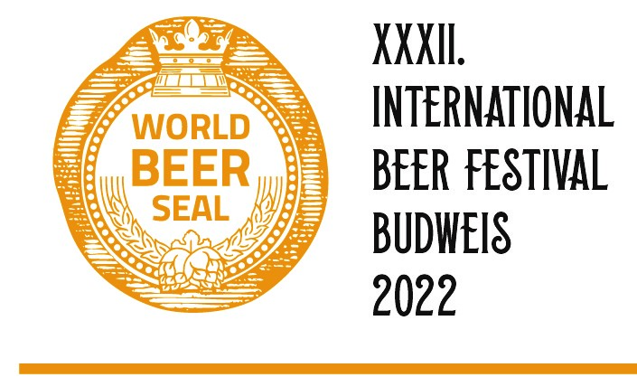

BINDING REGISTRATION FORM
WORLD CIDER SEAL 2022

Company:
Adress:
Reg. No: |  |  | VAT number:
Responsible representative:
e-mail: |  |  | Phone:

Our registered casting samples are as follows:
Trademark of product | Category
 | Select the category
 | Select the category
 | Select the category
 | Select the category
 | Select the category
 | Select the category
 | Select the category
 | Select the category

We agree with the invoice fee of 500,- CZK (20 € , 23 $) per each registered casting sample.
For the first time, two registered samples have free, free of charge.
We are interested in participating in public presentation at the festival as a business partner. YES/NO*

Date: |  | Signature (or name):

*Delete as appropriate

